Week 9 - S9 - Advanced OOP - Object Class Methods, Inner Classes - Lab Problem

**Name:**Ramesh Harisabapathi Chettiar

**Date of Submission:**15/10/2025

**QNO1🡪**

Create a Book class with title and author fields. Override the equals() method to

compare two books based on their title and author. Demonstrate the difference between == and

.equals() using two Book objects.

Hints:

● Use .equals() for content comparison and == for reference comparison

● Override equals() properly to avoid reference equality

● Use @Override annotation when redefining equals()

BookDemo.java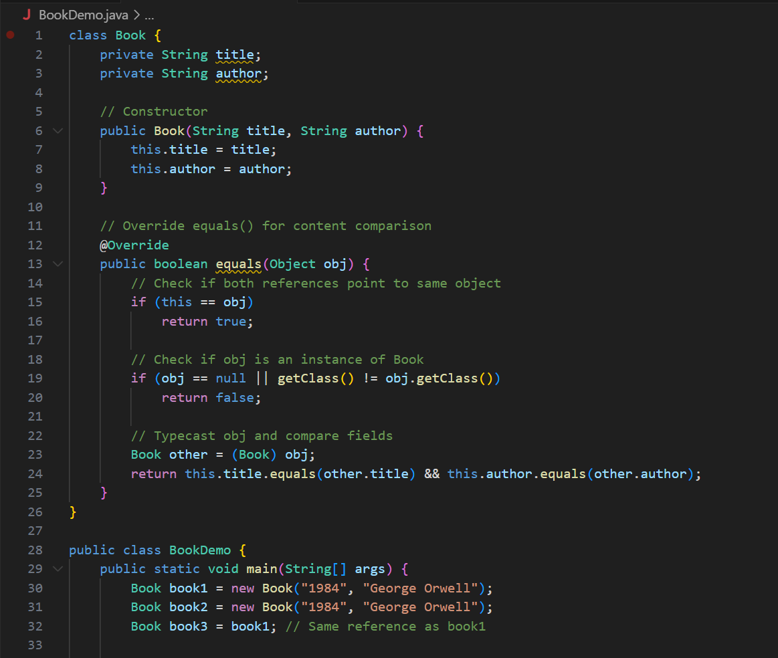 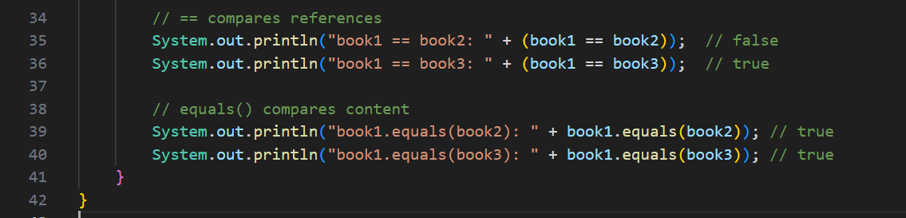

**OUTPUT🡪** 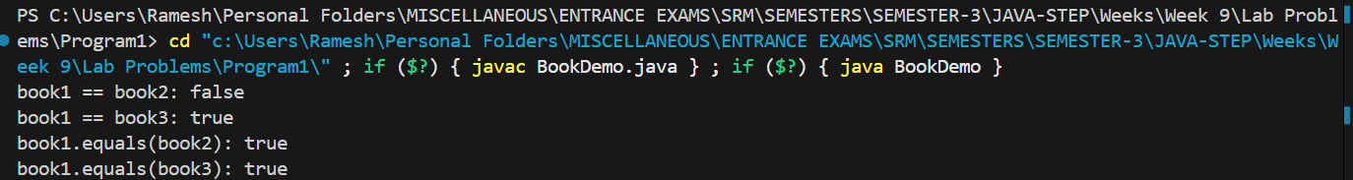

QNO2🡪

Create a Car class with brand, model, and price fields. Override the toString() method to

display object details. In the main method, print the class name of an object using

getClass().getName().

Hints:

● Use toString() for readable object representation

● Use getClass() to get runtime class information

● Print both the object (to invoke toString()) and its class name

CarDemo.java 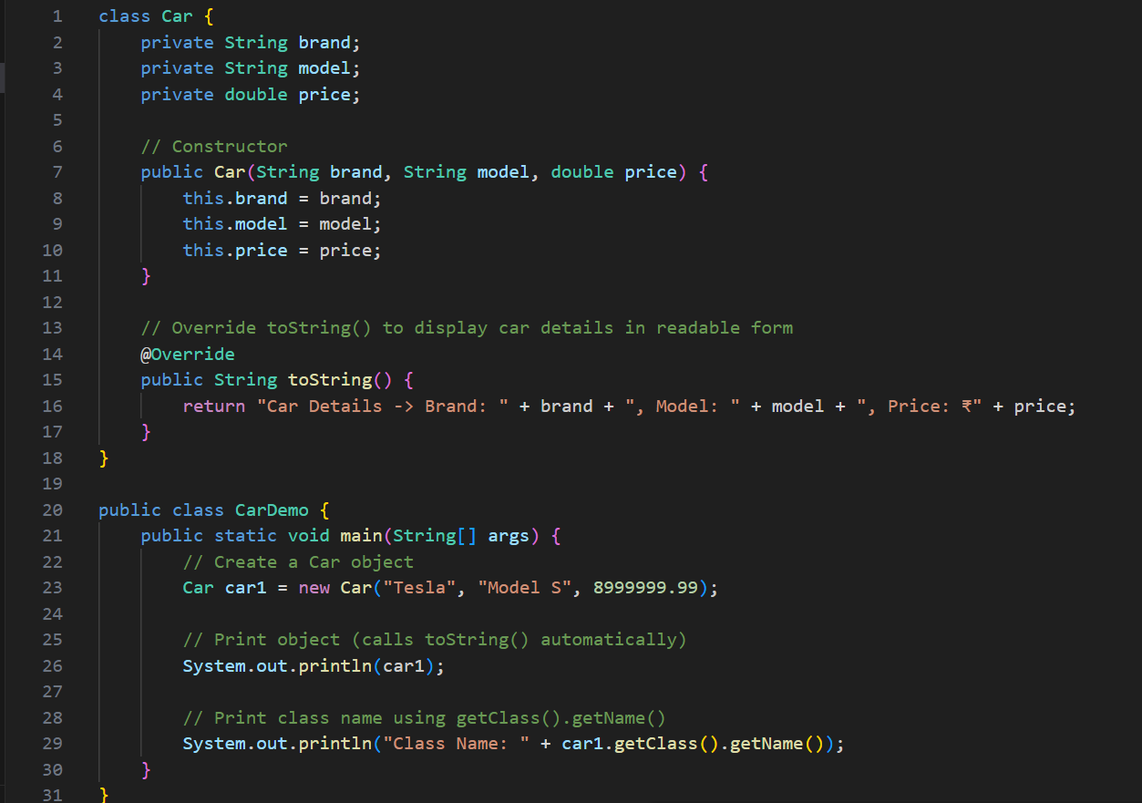

**OUTPUT🡪**

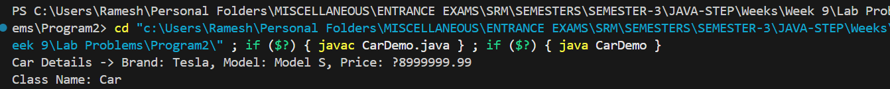

**QNO3🡪**

Create a Student class with id and name fields. Override both equals() and hashCode()

methods to ensure two students with the same id are treated as equal. Demonstrate storing

Student objects in a HashSet and show how duplicates are handled.

Hints:

● Use Objects.hash(id) for hashCode()

● Ensure consistent results for equals() and hashCode()

● Print HashSet elements to verify duplicates are avoided

**StudentDemo.java** 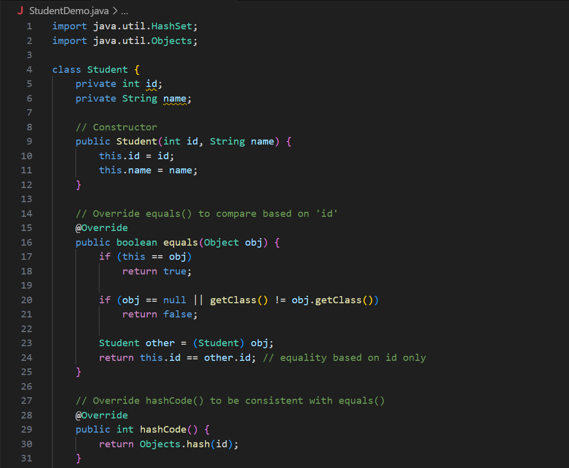 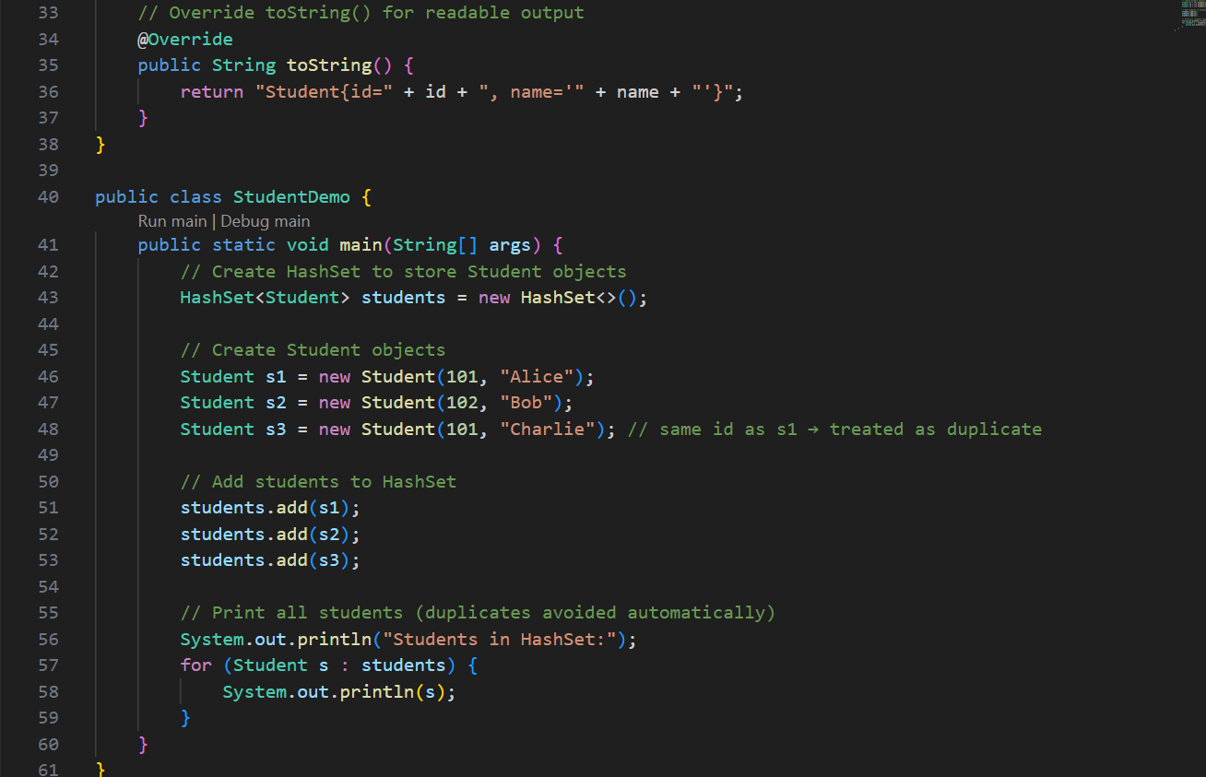

**OUTPUT🡪** 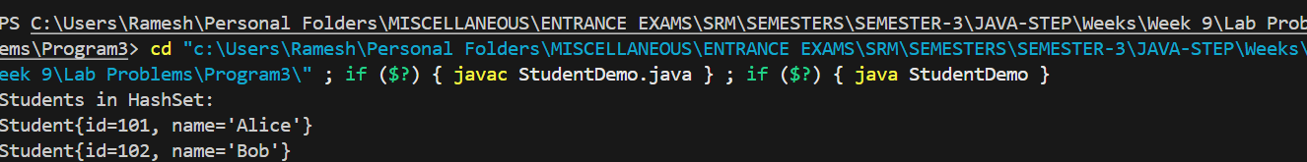

**QNO4🡪**

Create a Person class with name and Address object as fields. Implement Cloneable and

demonstrate both shallow and deep cloning.

Hints:

● Use implements Cloneable and super.clone()

● For deep copy, create a new Address object manually in clone()

● Print original and cloned objects to compare changes

**CloneDemo.java** 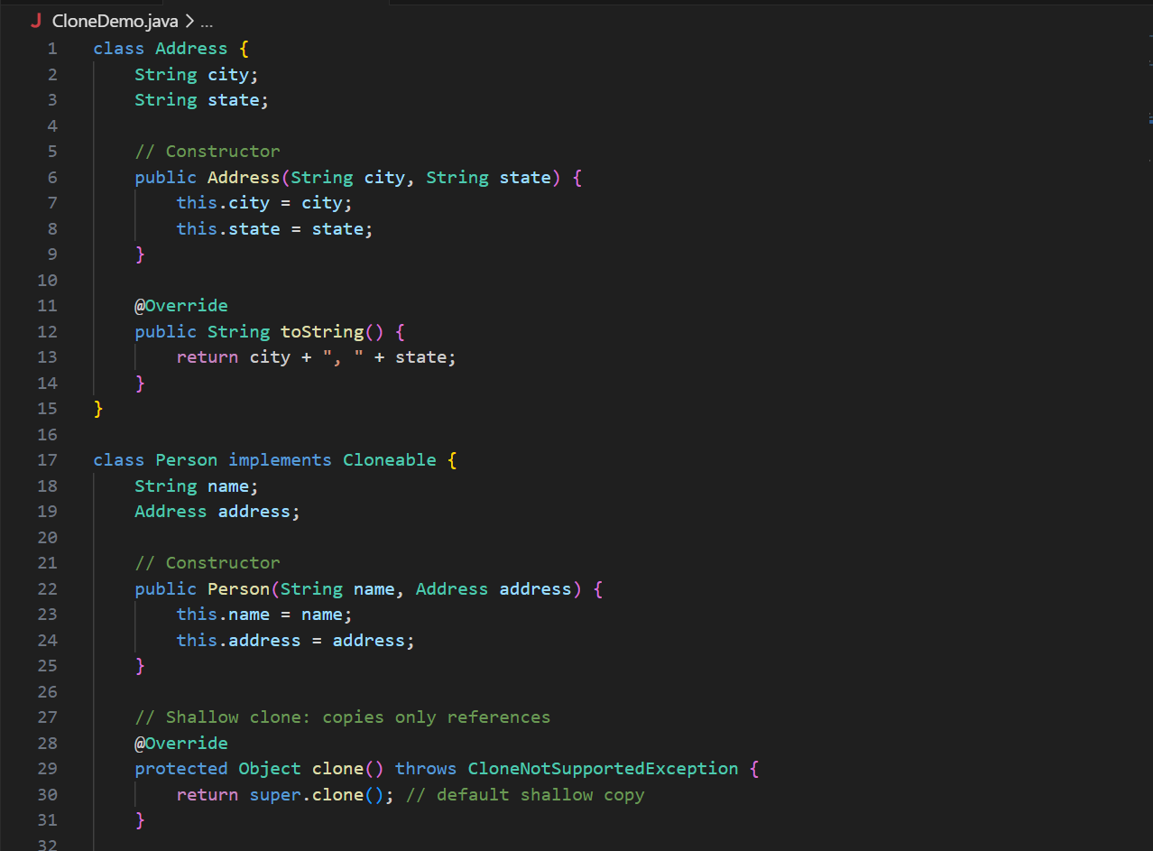 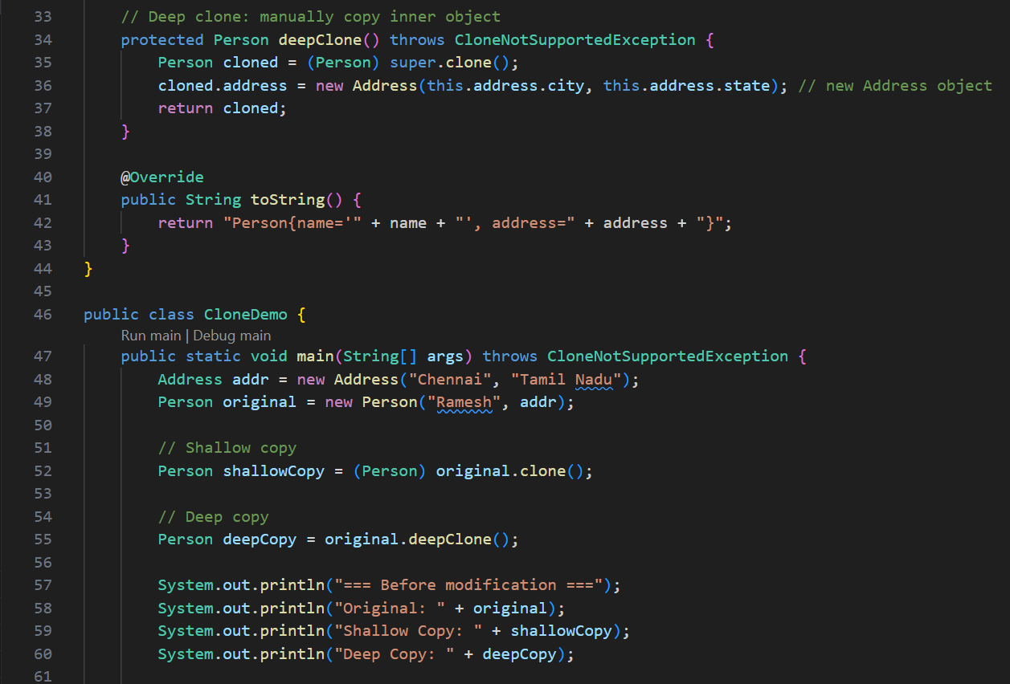 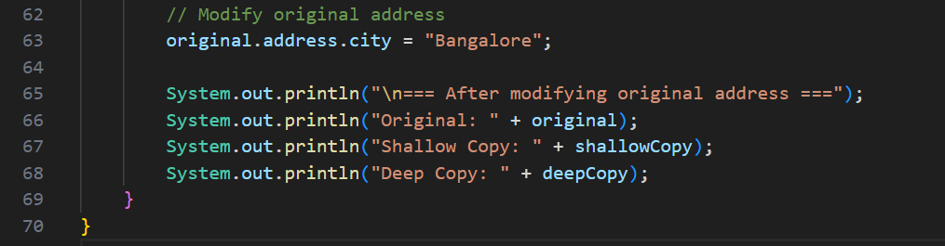

**OUTPUT🡪** 